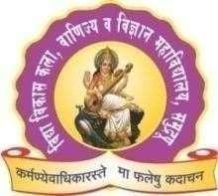**VIDYA VIKAS SHIKSHAN SANSTHA, HINGANGHA**

VIDYA VIKAS ART’S, COMMERCE & SCIENCE COLLEGE, SAMUDRAPUR, DIST. WARDHA 442305 (M.S.)

(Affiliated to Rashtrasant Tukdoji Maharaj Nagpur University, Nagpur.) NAAC Reaccredited B++ ( CGPA: 2.8 )

**PROGRAMME REPORT**

# **Name of Program / Event:** Induction Programme

* **Name of the Organizing Department:** Department of Commerce

# **Date, Venue, Time/ Duration:** 1 August 2023 Time 12:00 AM

* **Number of participated students/ faculty members/ research scholar:** 40 Students and 06 Faculty members

# **Introduction of the event:**

The induction programme has been organized for the students of B. Com. I to introduce the faculty members of this department and their subjects through this program, these students have been made aware of the various activities and programmes organize by the department throughout in the year.

# **Objective of the event:**

1. To welcome the students.
2. Introduction of the students.
3. To inform them about the subjects and Syllabi.

**Photographs:**

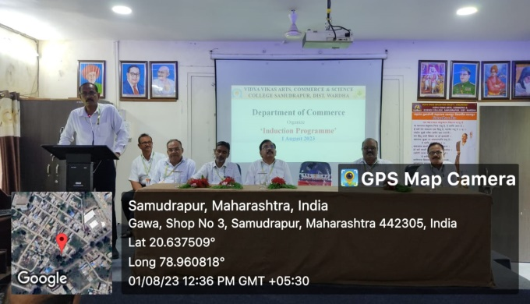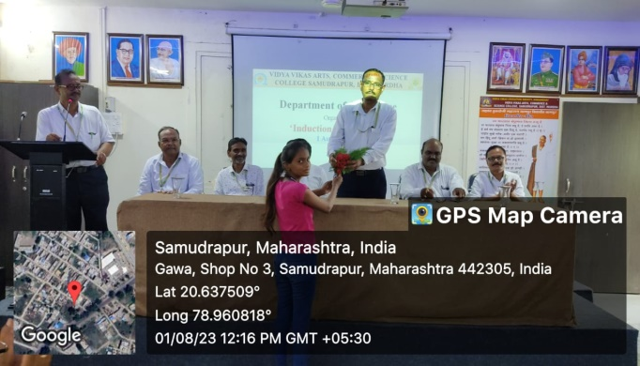

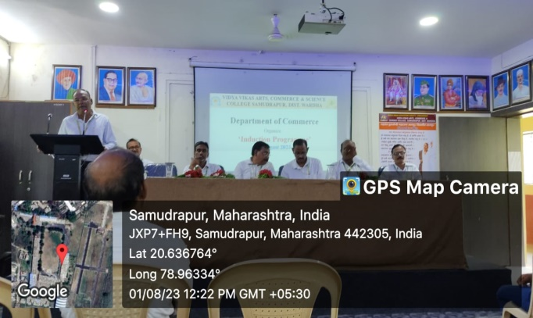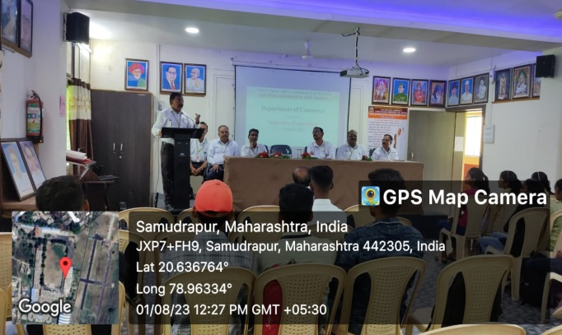

**Outcome:**

1. The teachers and students introduced themselves with each other.
2. The students come to know about the subjects and syllabus they are going to learn.

**Name and Sign of event In charge**

Dr. Ramesh Nikhade

Head, Department of Commerce

**Date: 1 August 2023**

**Place:** Samudrapur

